**MongoDB**

* **By Tushti Gupta**
* **Creating Collection Sales in SalesData Database**

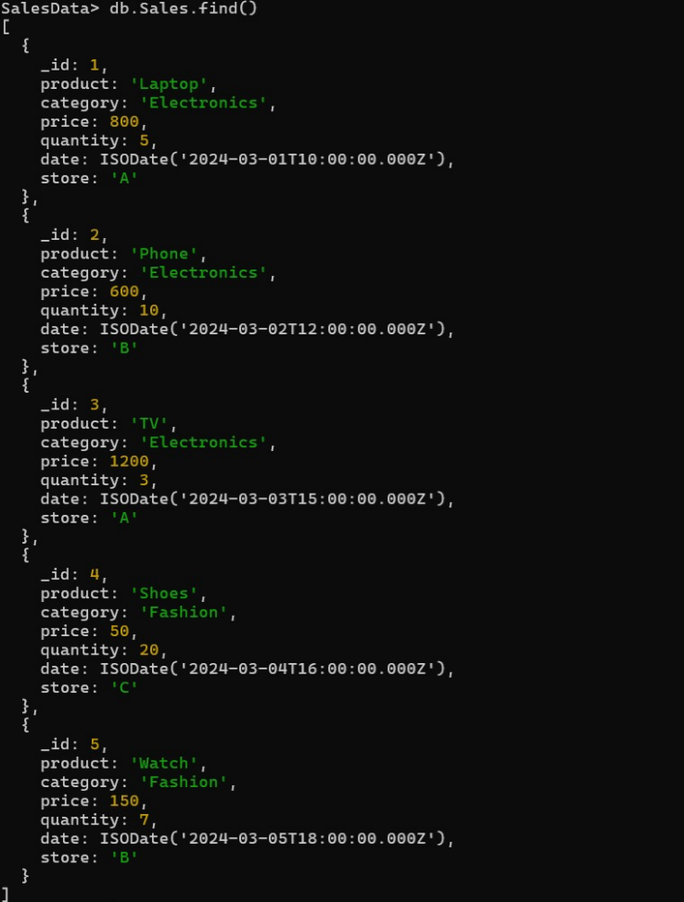

* **Total sales per product.**

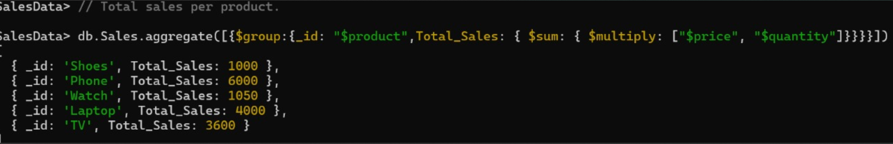

* **Total revenue per product.**

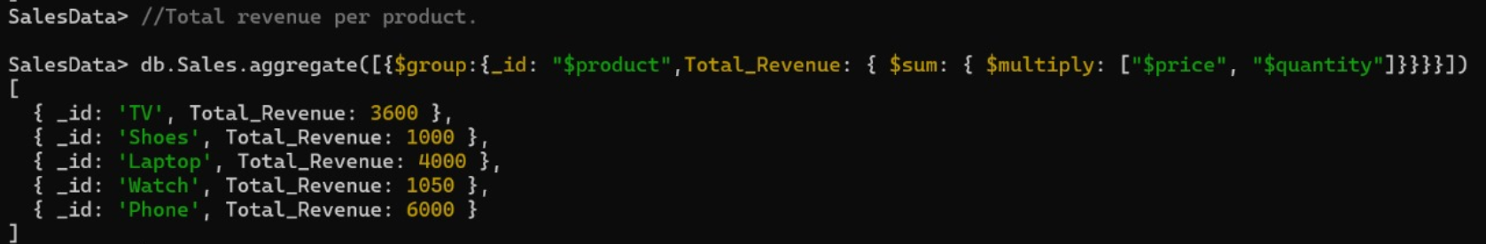

* 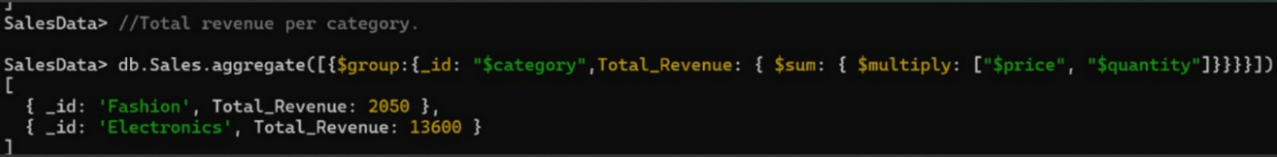**Total revenue per category.**

* 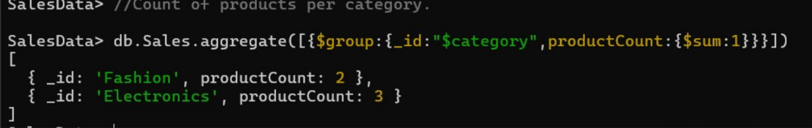 **Count of products per category.**

* 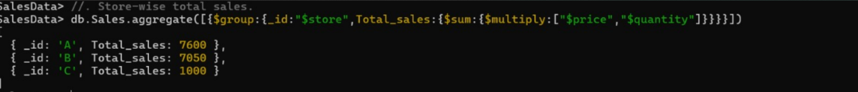**Store-wise total sales.**

* 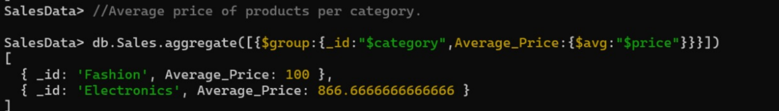**Average price of products per category.**
* 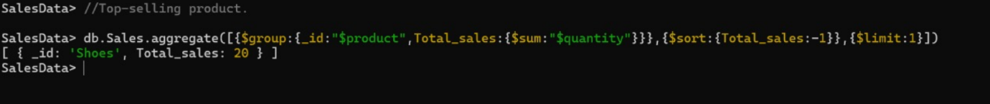**Top-selling product.**

* **Total sales for Electronics category.**

* 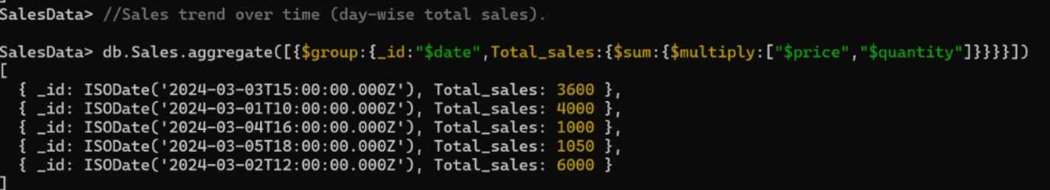**Sales trend over time (day-wise total sales).**

* **Highest revenue-generating product.**
* **Average revenue per sale.**

* 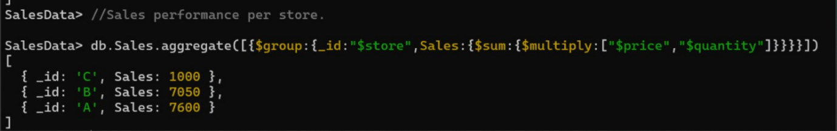**Sales performance per store.**
* 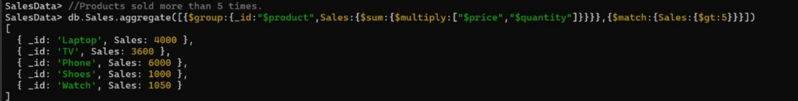**Products sold more than 5 times.**
* **Least sold product.**

* 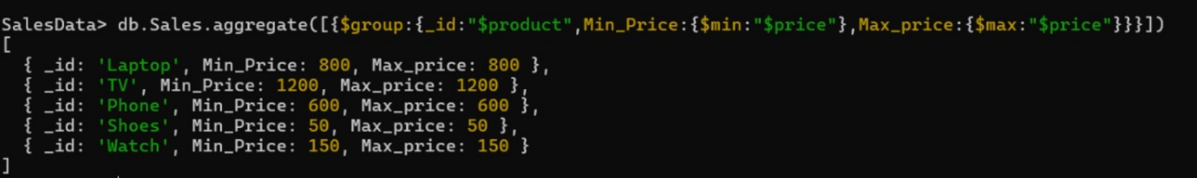**Maximum and minimum priced product.**

* 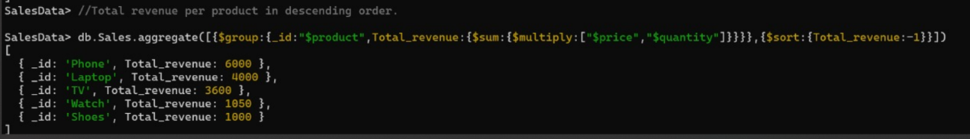**Total revenue per product in descending order.**

* **Revenue generated per store per category.**

* **Products contributing more than 50% revenue.**

